**Section 8**

***Drag State to the sheet and use Map***

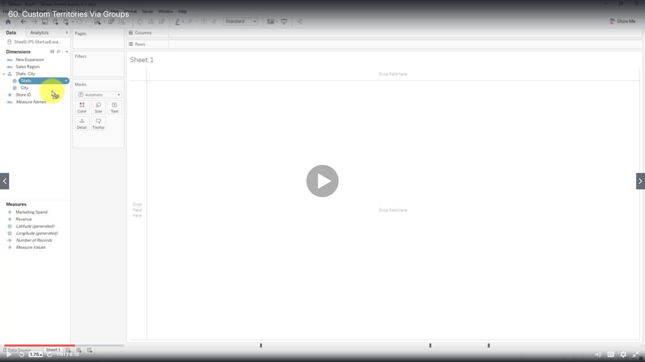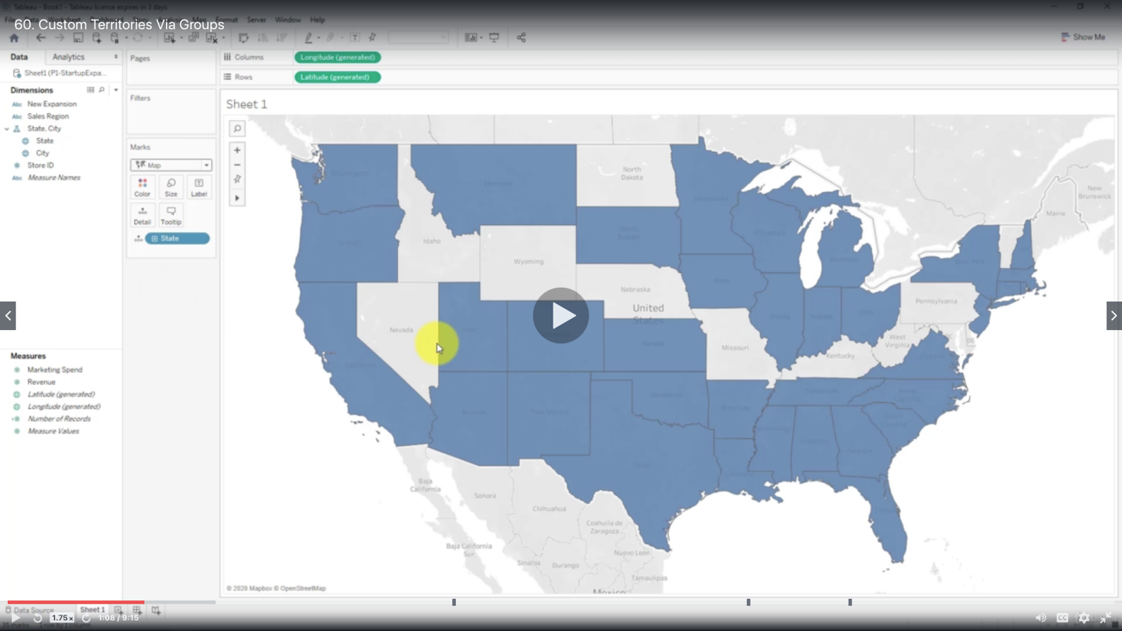

Add Region to Details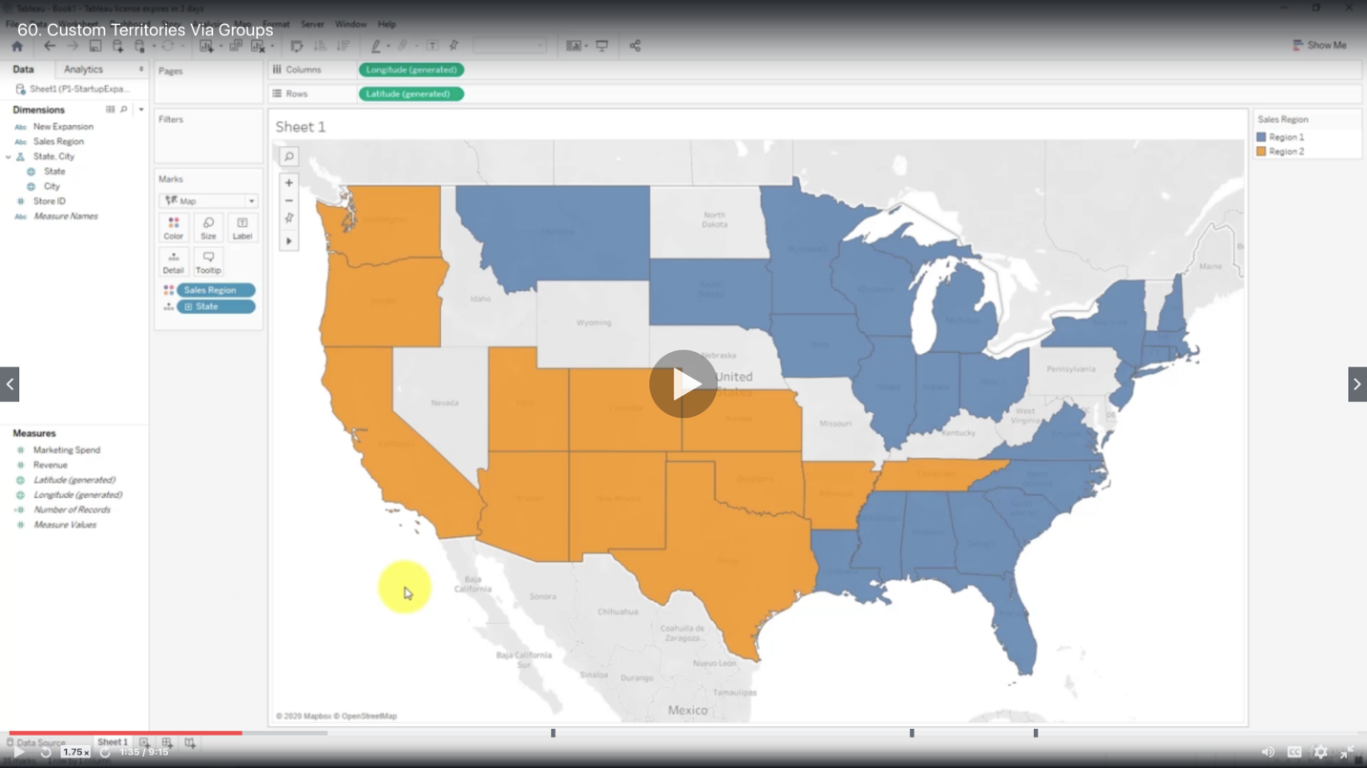

Add Revenue to Labels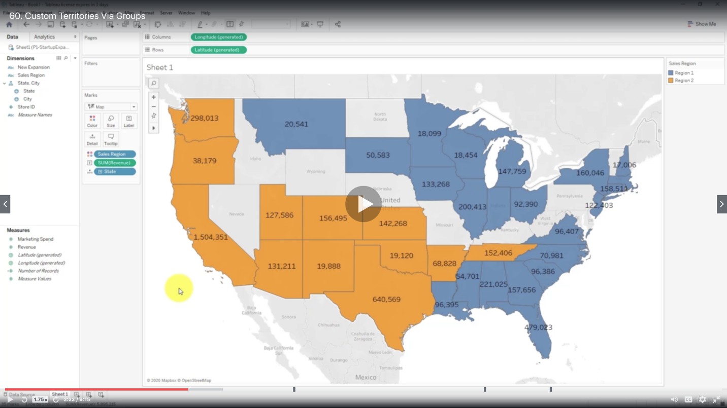

Show as Average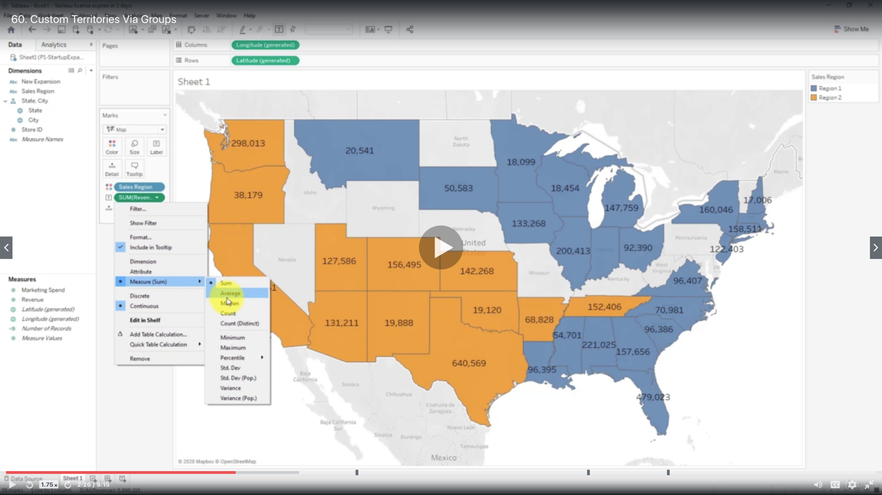

***Custom Territories Via Groups***

Hold on Ctrl and select the states you want to include in the group

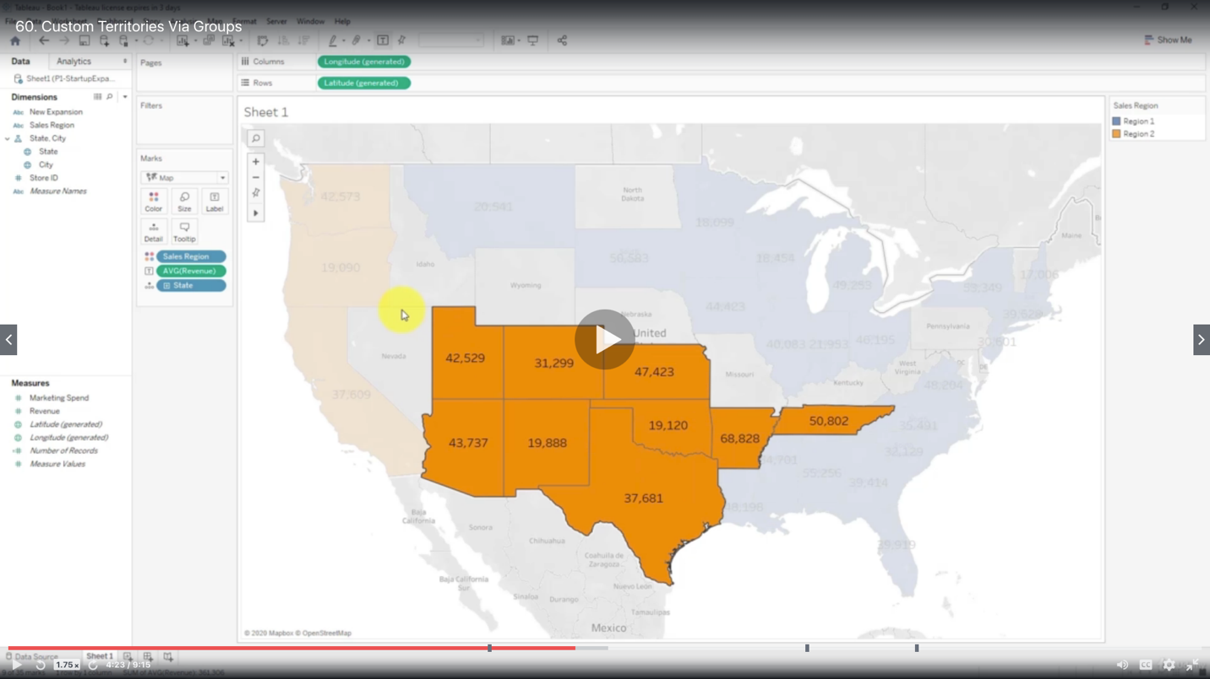

Right click and Group all dimensions

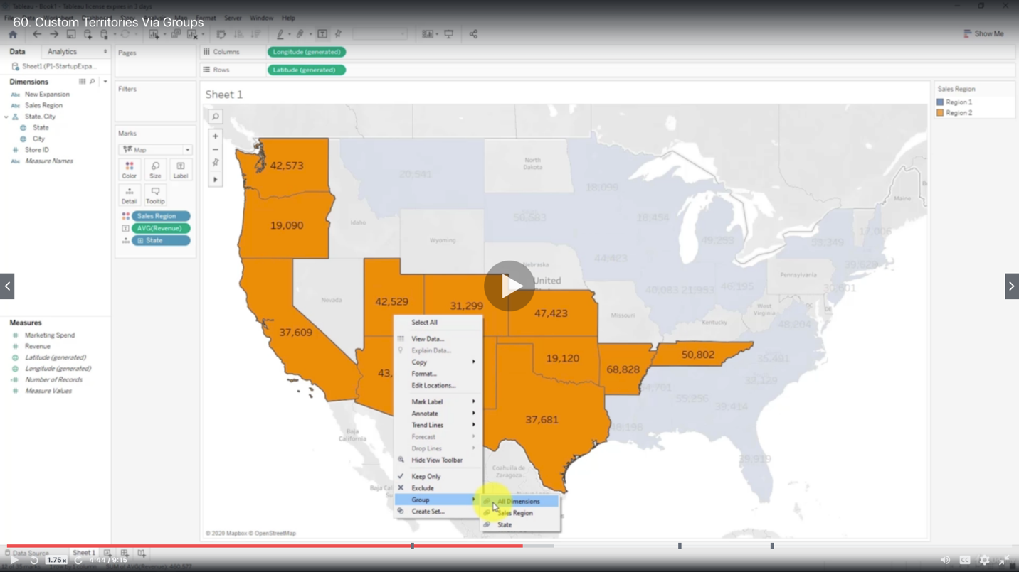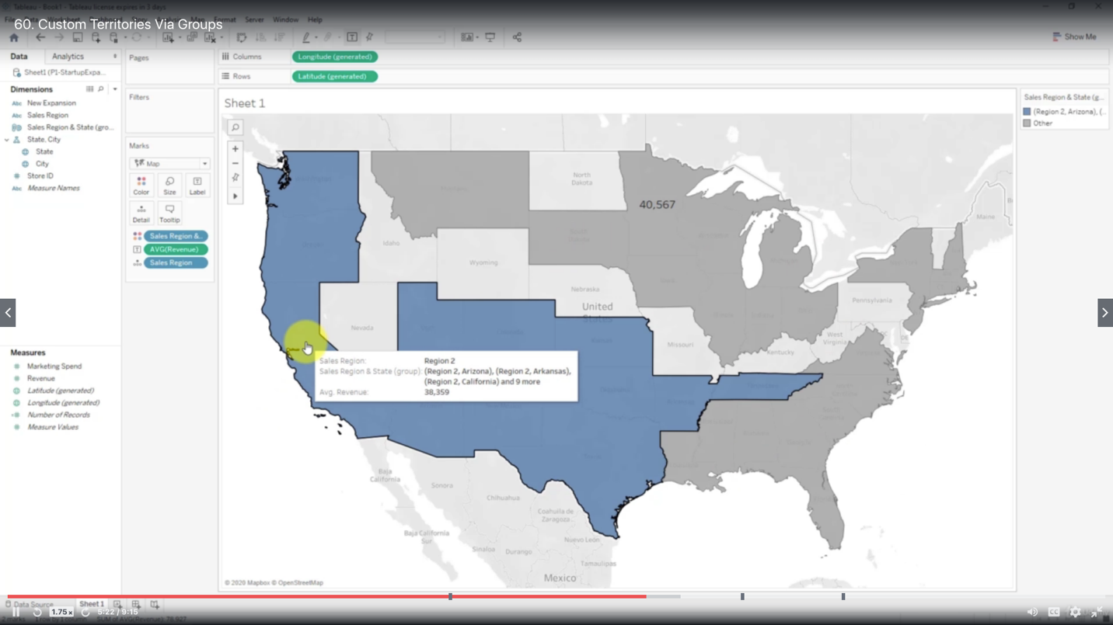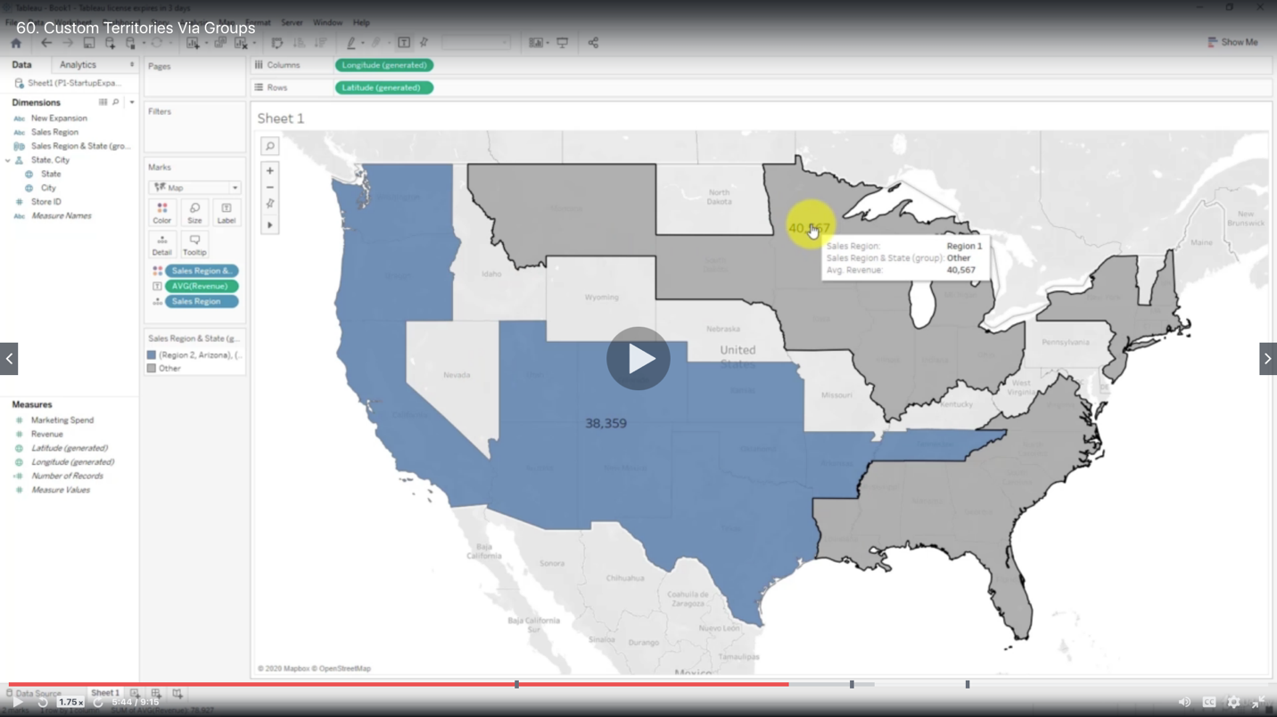

You may edit the groups

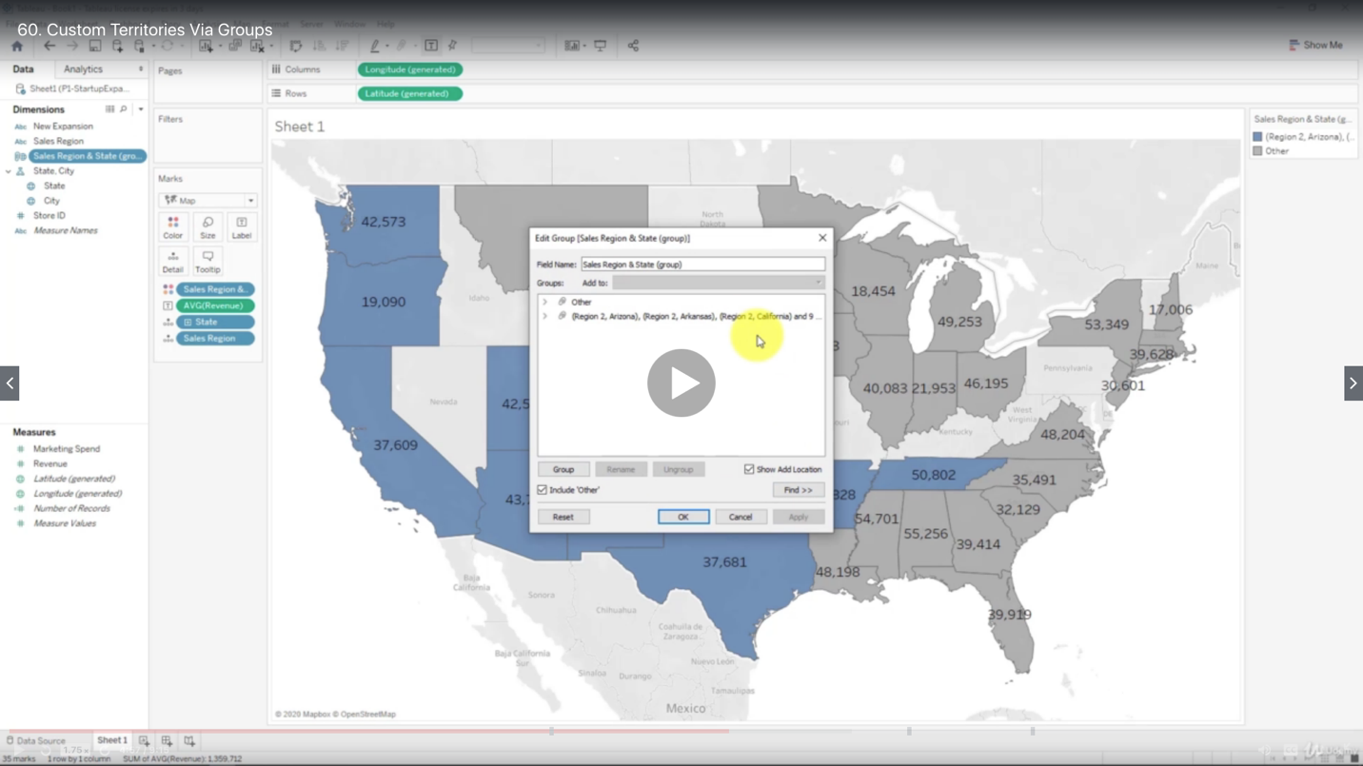

Create a Calculated Field

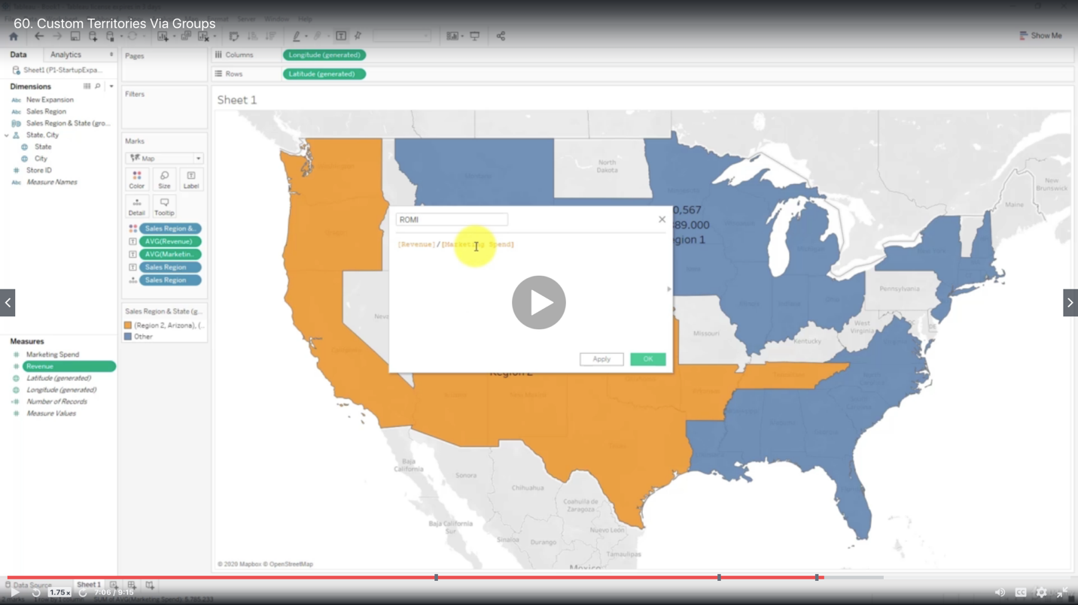

Edit Labels

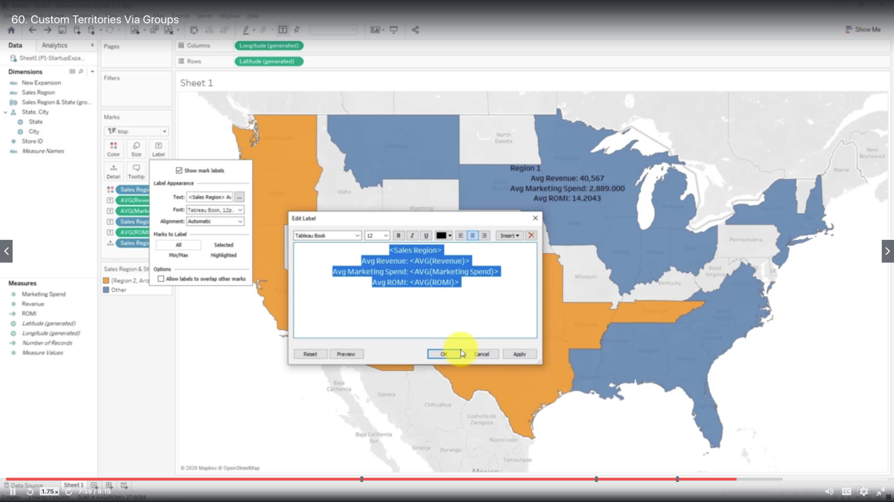

***Custom Territories Via Geographic Roles***

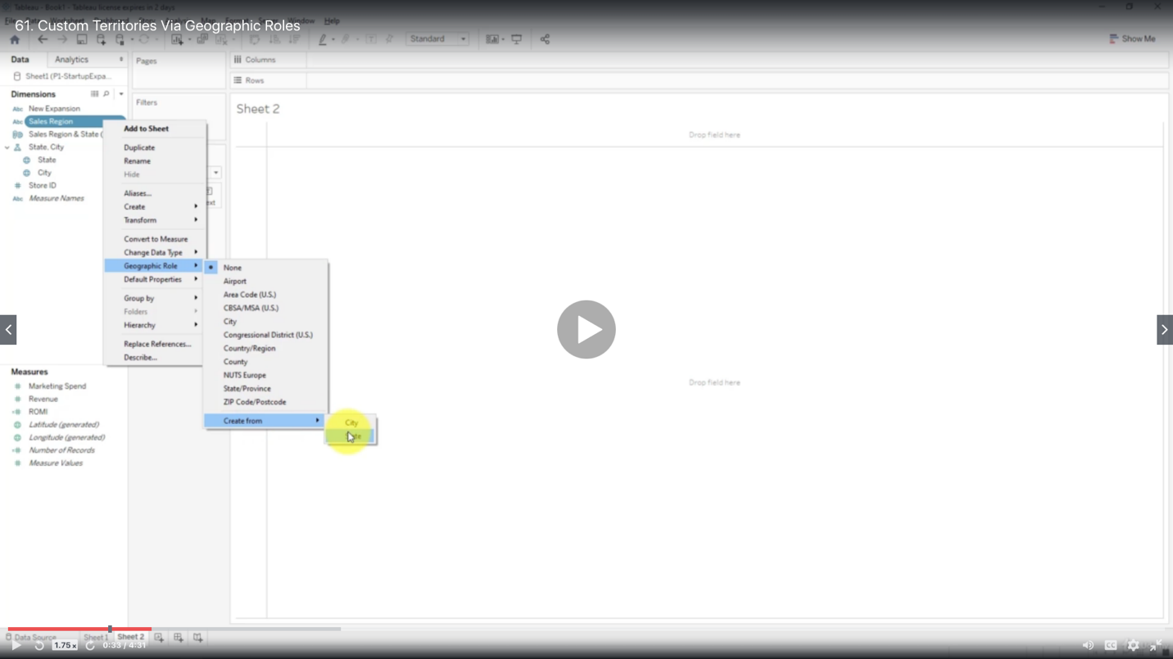

The Groups are shown as dimension

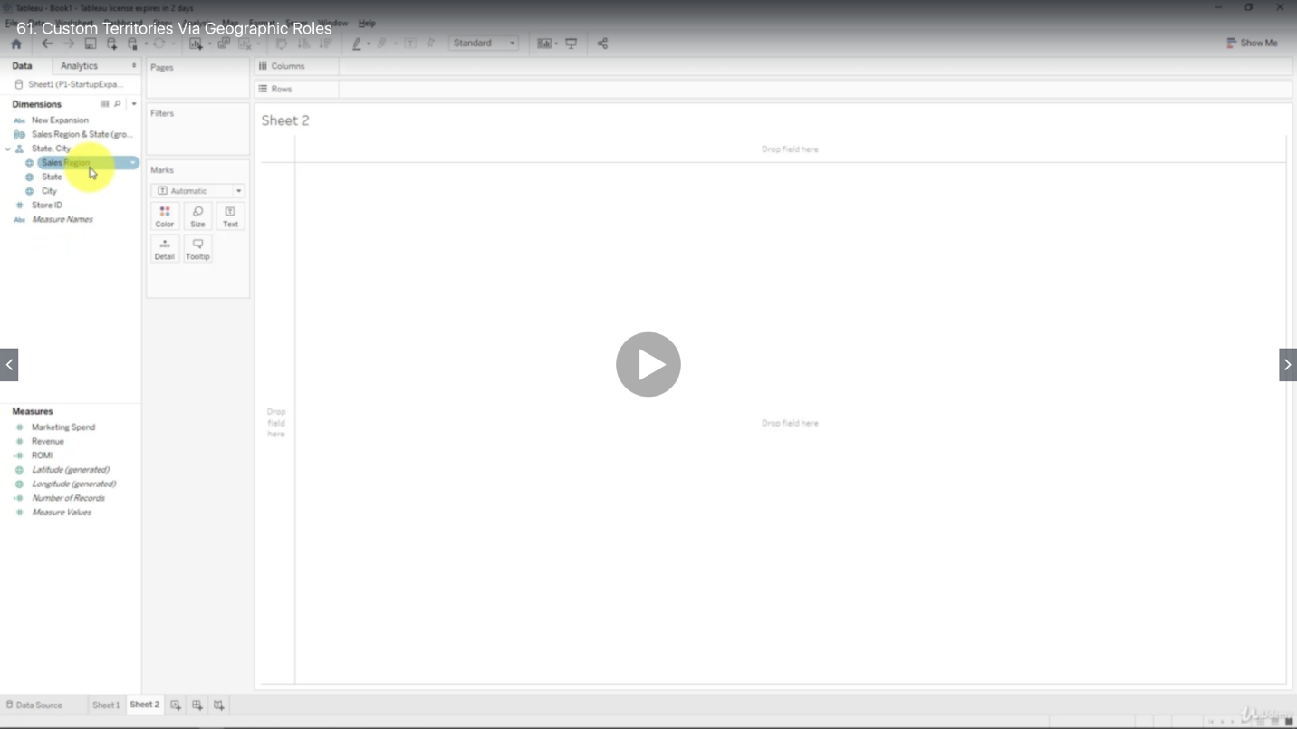

***Cross-Database Joins***

This does not render blends completely useless

Blends are still relevant. Blend is a LEFT join that happens AFTER the data has been aggregated to the required level.

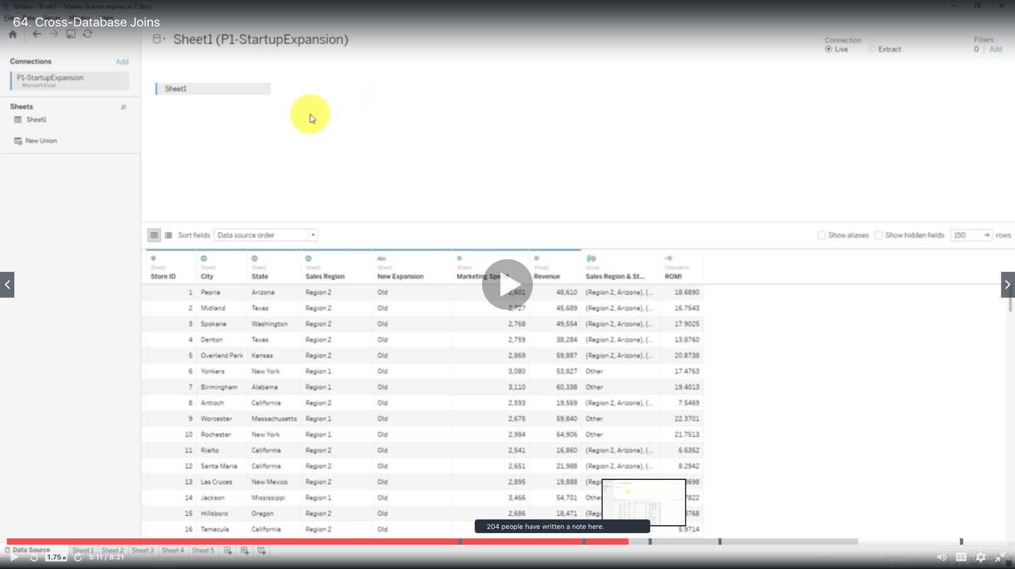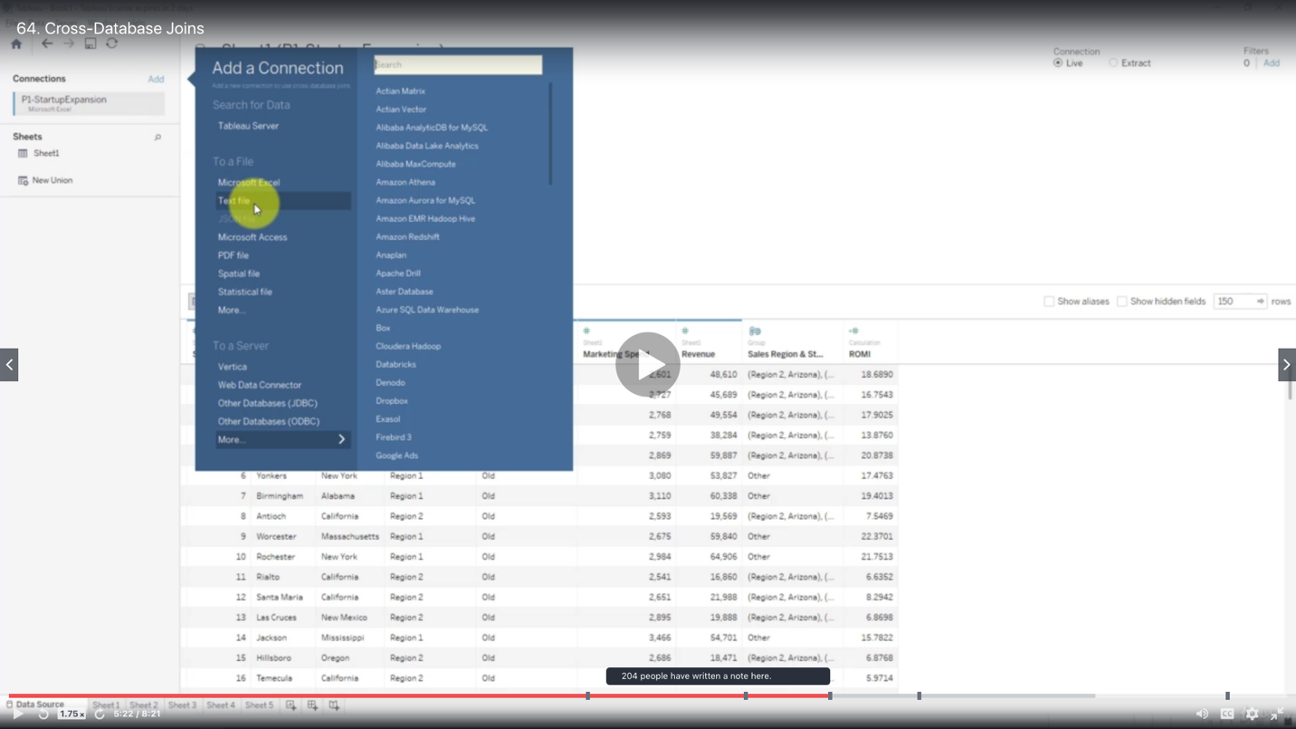

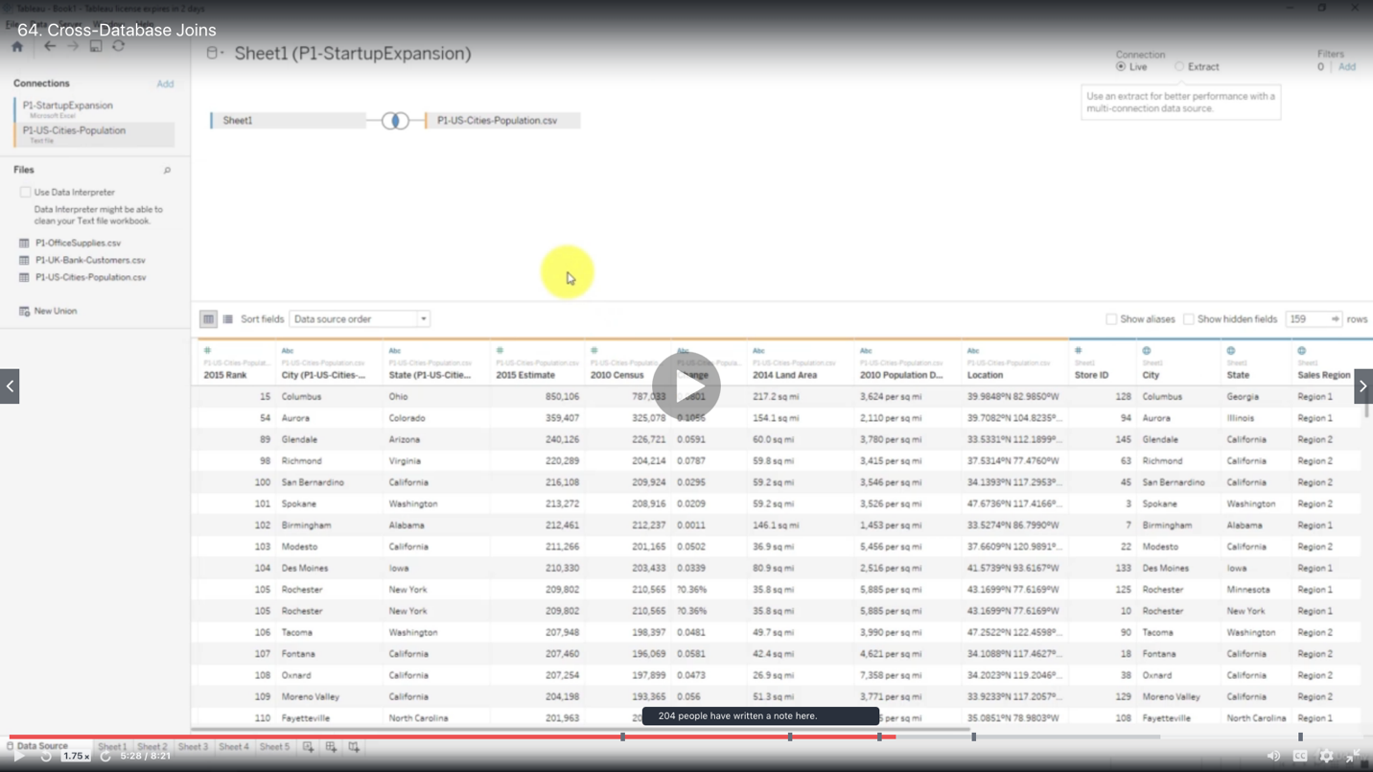

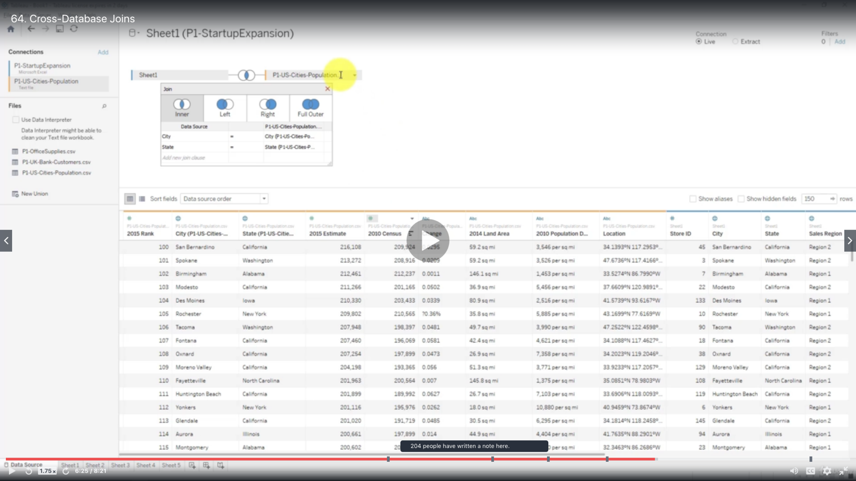

***Adding a highlighter***

A highlighter allows you to subtly highlighter different marks on your chart based on categories within the selected field without interfering with the chart’s visual representation (mark sizes, colors, etc.)

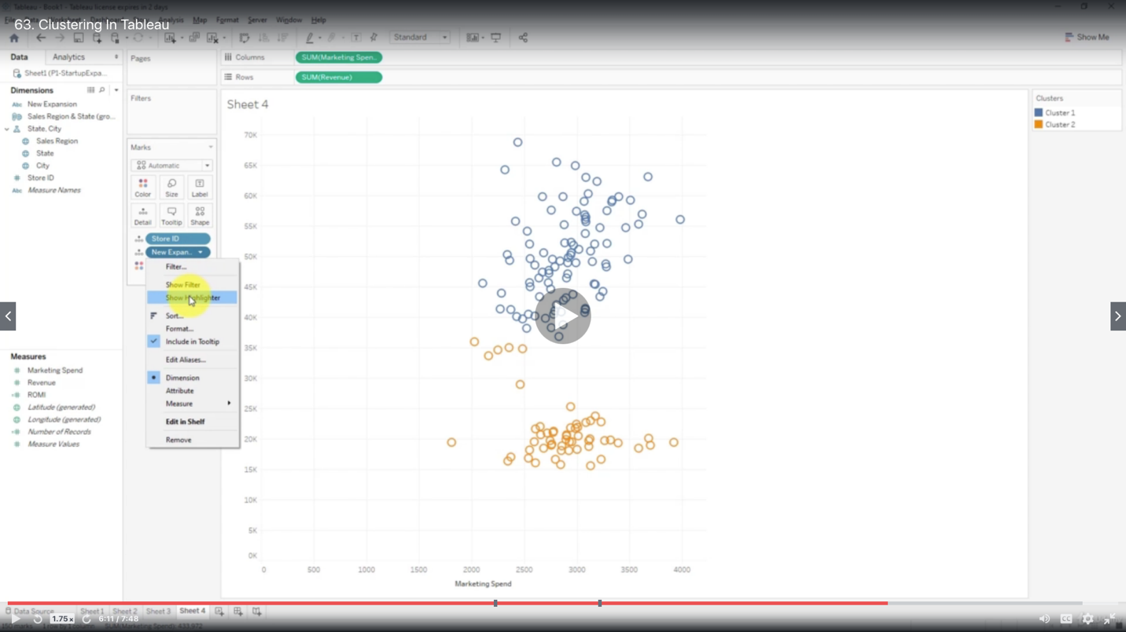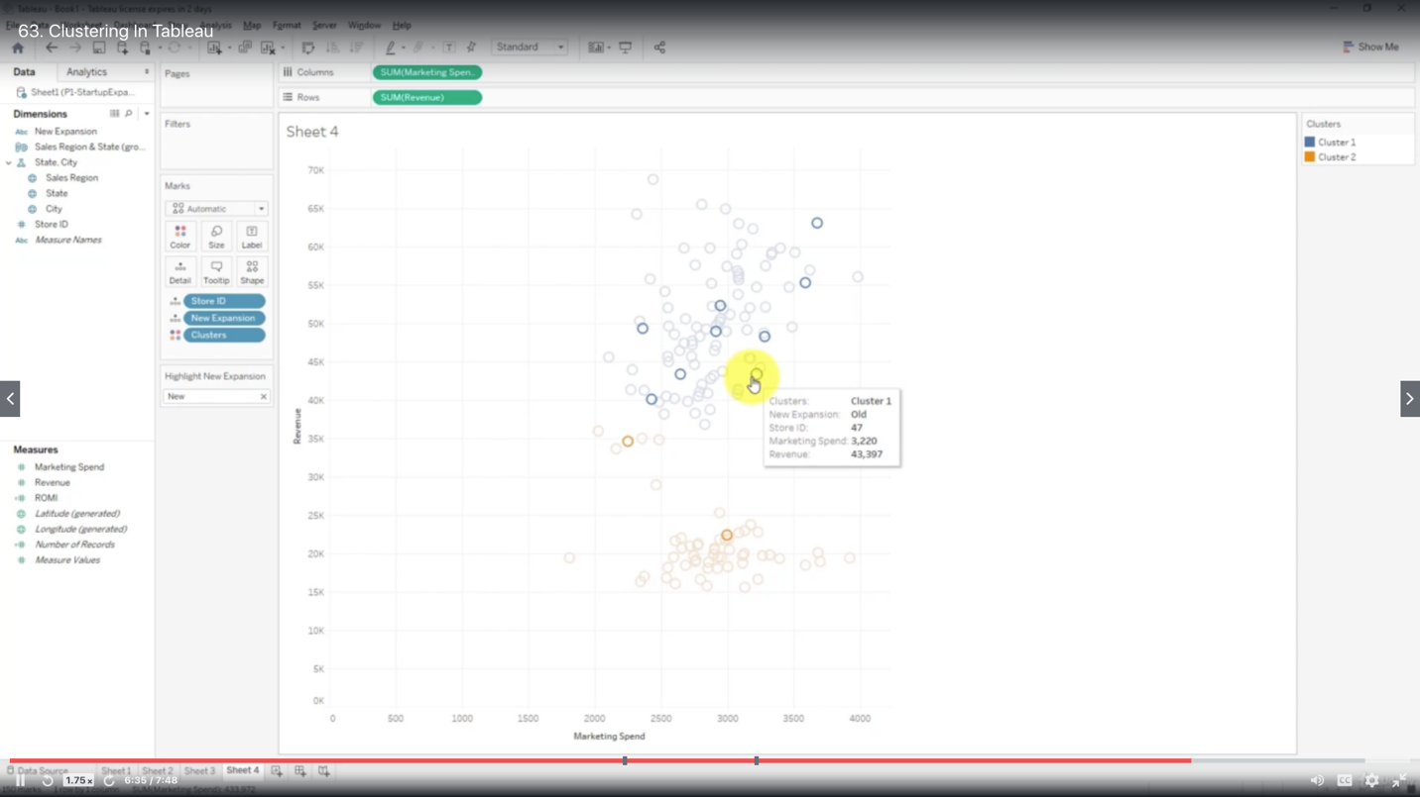

***Clustering In Tableau***

Clusters are a dimension - because they represent a categorical split of your data

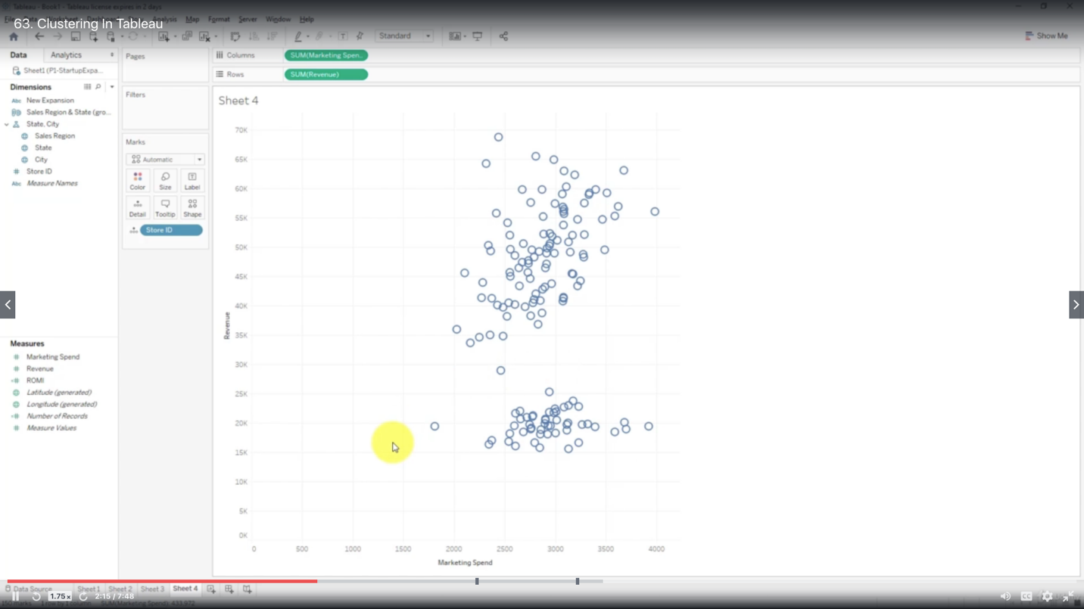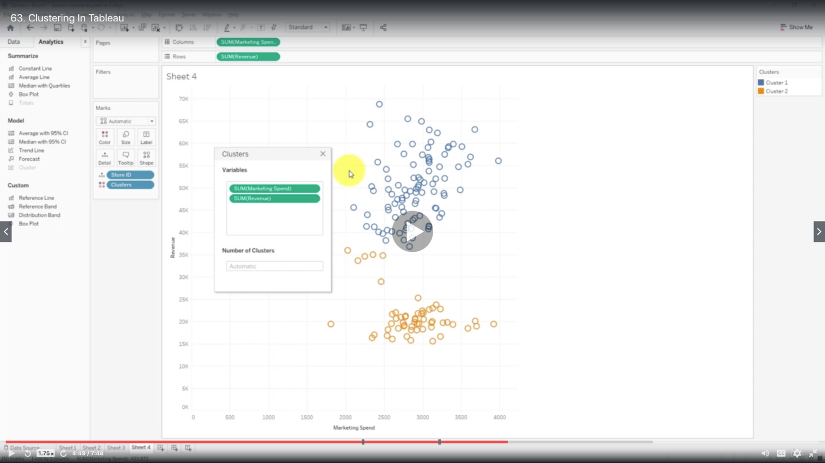

You may specify the number of clusters or leave it empty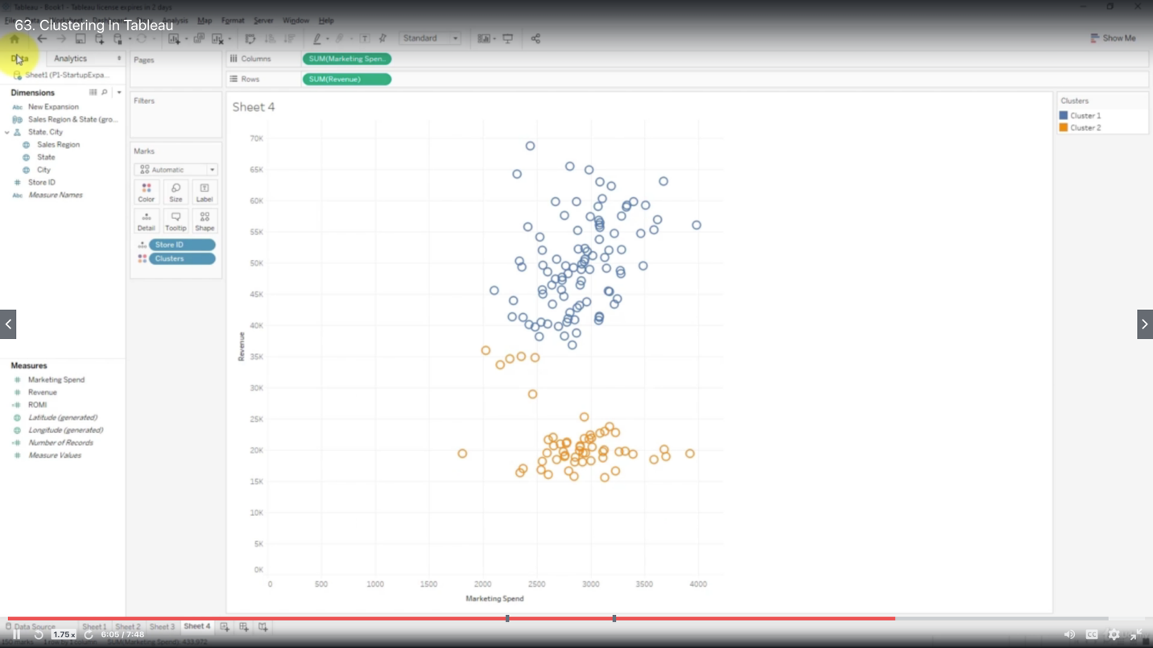

You can specify additional variables, AND you can remove unwanted variables from the clustering analysis without removing them from the chart

Edit clusters

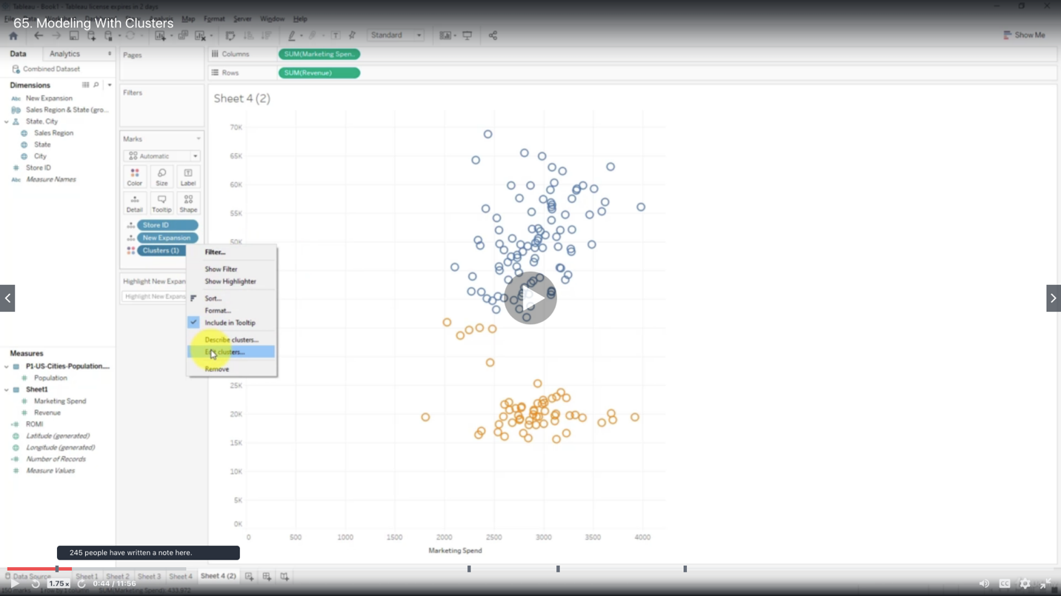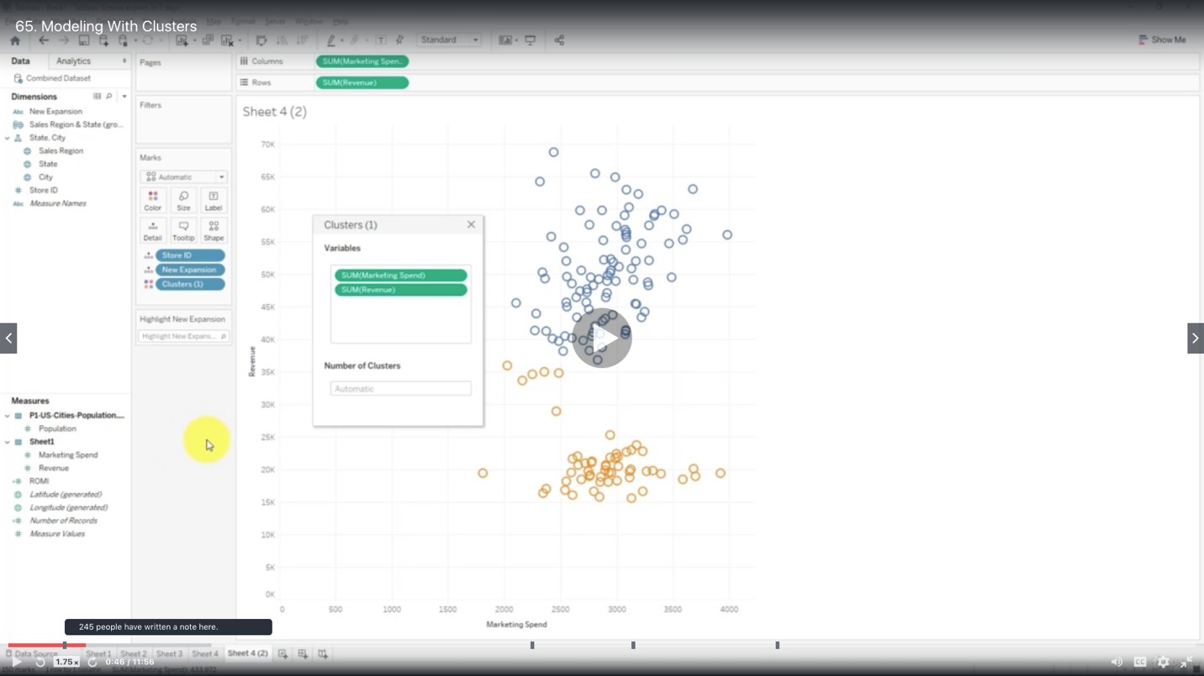

Add additional variables for clustering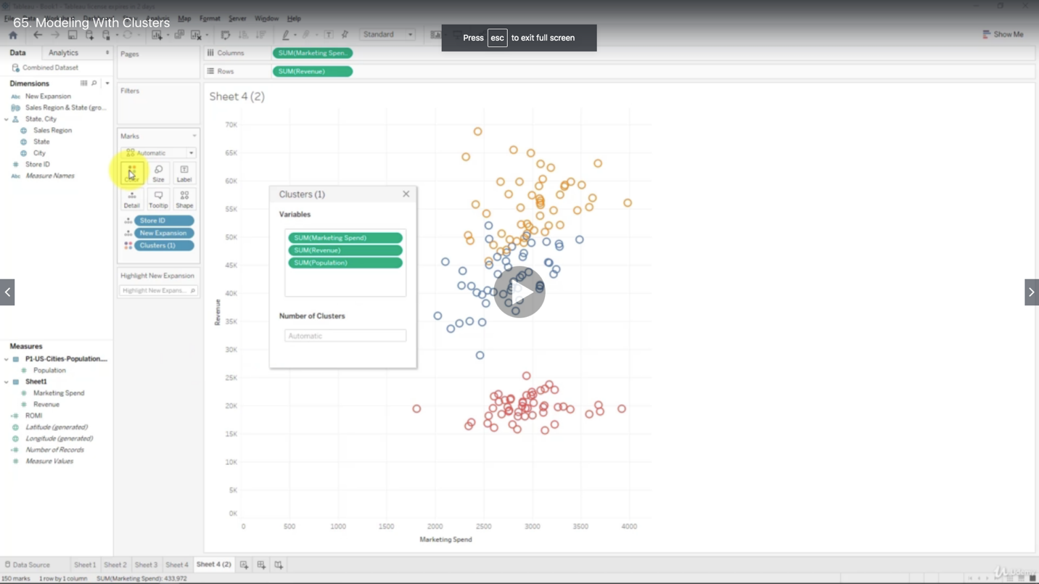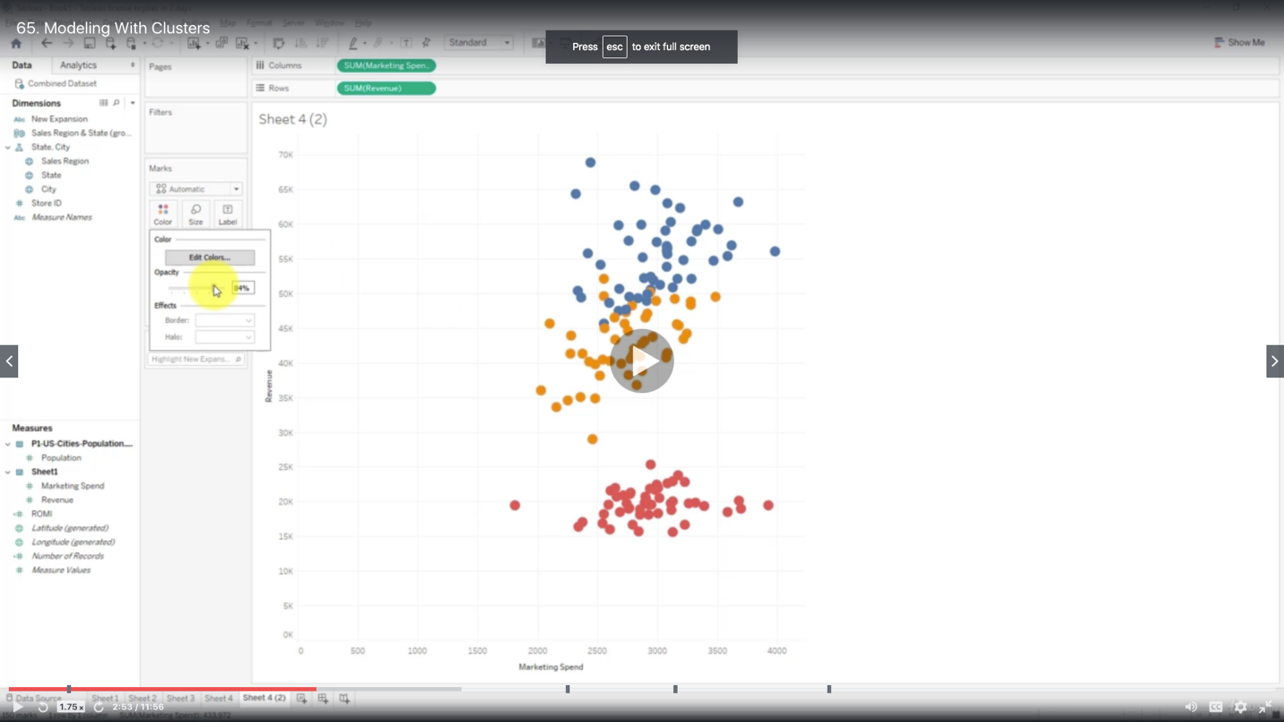

***Modeling With Clusters***

Add Trend Line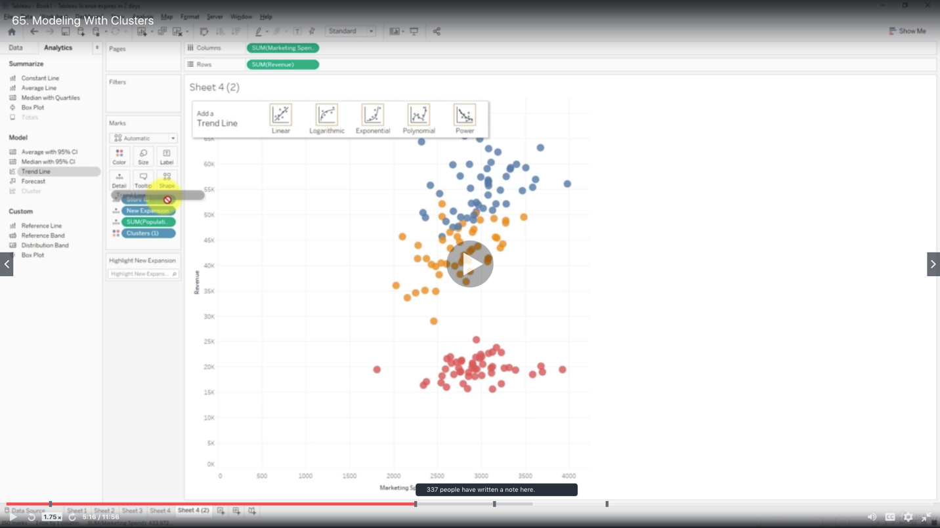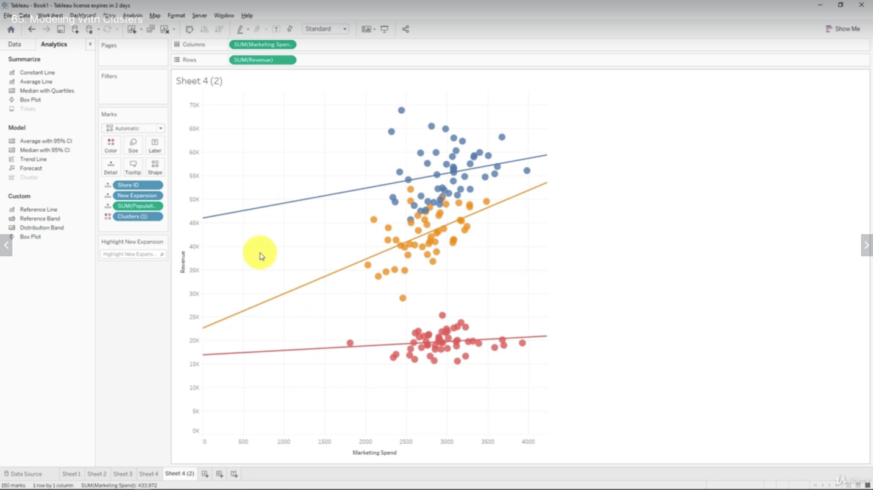

Add highlighter

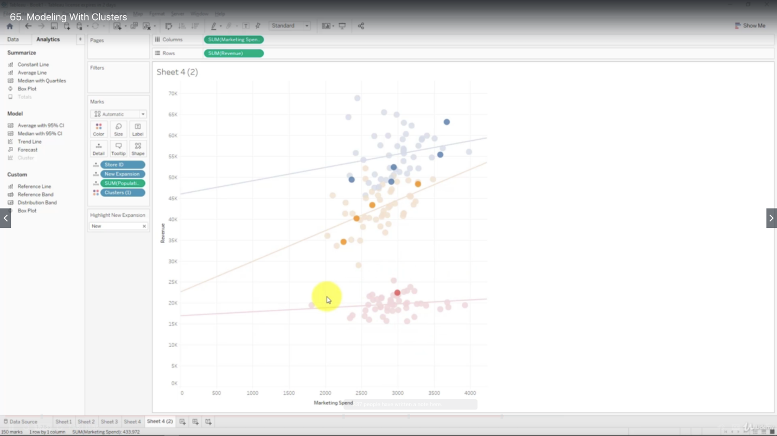

Untick show recalculated line for highlighted or selected data points if necessary

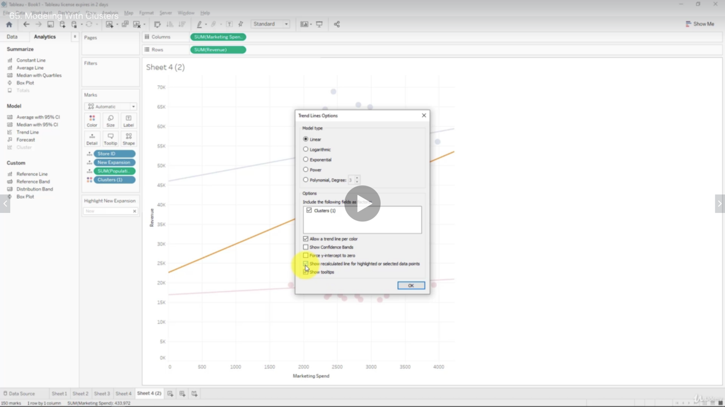

**Saving your Clusters**

and use for other data

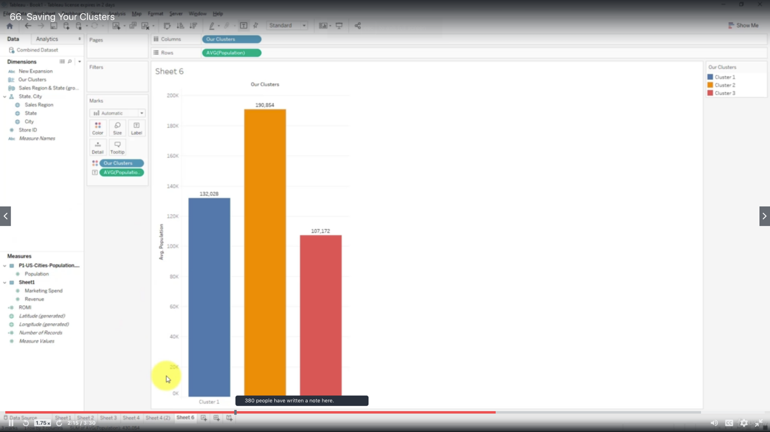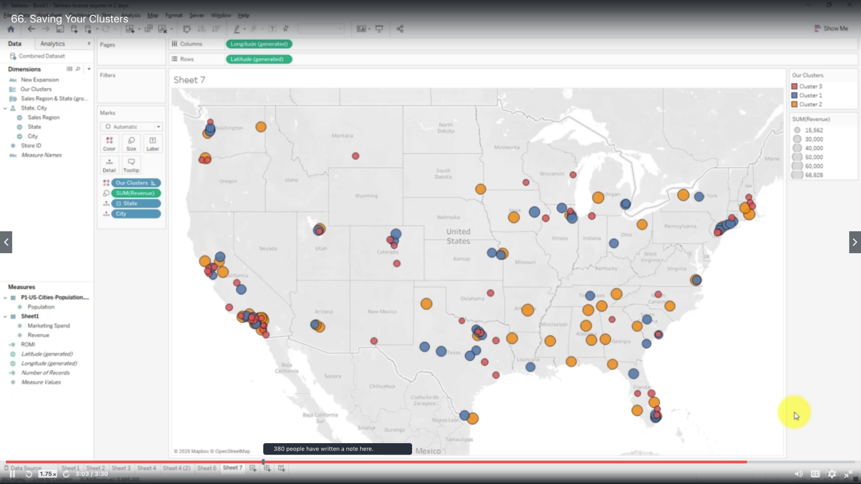

***New Design Features (in Tableau 10)***

- Custom Territories

- Cross-Database joins

- Clustering analytics

(x) 3s-Dimensional dashboards

